The Painted Pot
3772 Monticello Plaza
St. Charles, MO 63304
636.300.4515
Thepaintedpotstl@yahoo.com
School Program Project Order Guide
Daily Basics
 | Product # | Product Name | Measurements | Price
 | 66 | 6” Tile | 6”L x 6”W | $8.50
 | 4002 | The Perfect Mug | 12oz | $10.00
 | 1031 | Salad Plate | 8”D | $10.00
 | 144 | Bowl | 5”D x 2 ½”H | $10.00
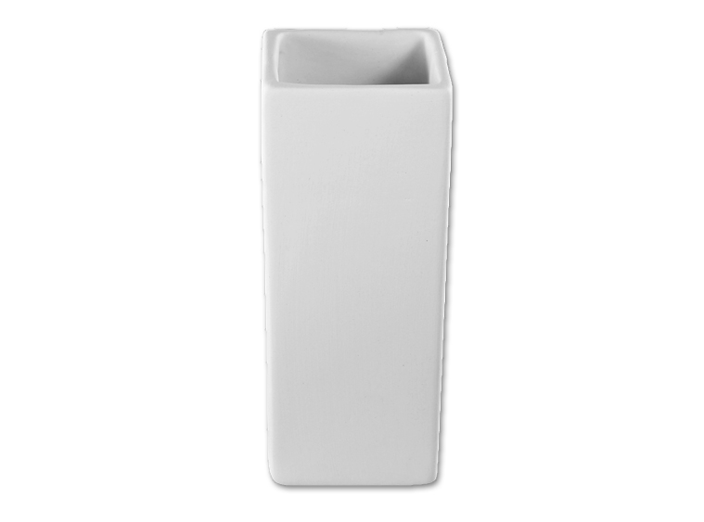 | 699 | Vase | 5”H x 2”D | $10.00
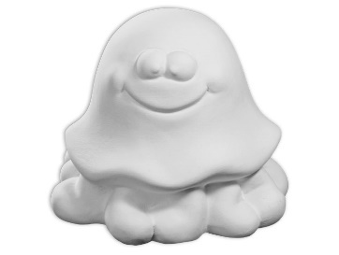 | 1400 | Picasso Party Pals  ( Animal Variety ) | Varies 3”- 4”H | $10.00
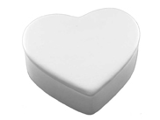 | 1254 | Sm Box Variety  (Heart, Star, Round) | Varies  3”W X 2 ½” H | $10.00
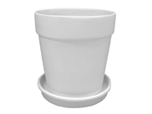 | 5057 | Sm. Flower Pot | 4”D x 4”H | $15.00
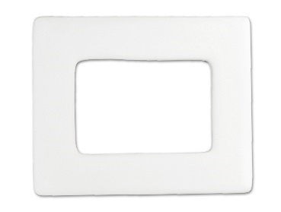 | 1823 | Picture Frame | 5”L x 4”W | $15.00

Halloween
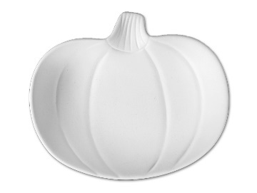 | 2172 | Petite Pumpkin Dish | 5 ¼”L x 4 ¼”W | $10.00
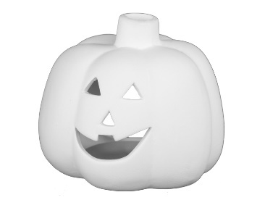 | 2117 | Sm. Pumpkin Votive | 3 ¼”W x 2 ¾”H | $10.00

Christmas
 | 2090 | Flat Ornament | Varies about 4”H | $8.50
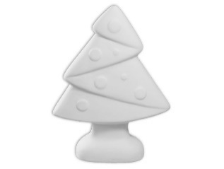 | 2008 | Jubilant Tree | 5 ¼”H x 1 ½ W | $10.00
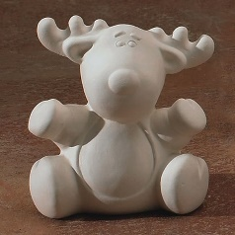 | 7233 | Holiday Collectibles  (Santa, Snowman & Reindeer) | 3 ½” H | $10.00
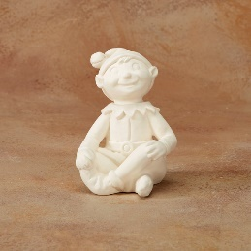 | 5235 | Sitting Elf | 5”H x 3 ½” W | $15.00

Valentine’s Day / Mother’s Day
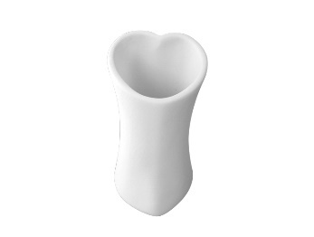 | 698 | Sm Heart Vase | 4”H x 2 ½” W | $10.00
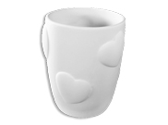 | 2741 | Heart Cup | 4”W x 3”D | $10.00
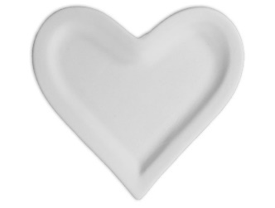 | 2594 | Rim Heart Dish | 6 ¼”W x 6”L | $10.00

Easter / Communion
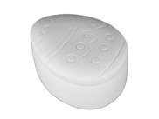 | 1283 | Easter Box | 4” L x 2 ½” H | $10.00
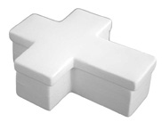 | 1312 | Cross Box | 4” L x 1 ¼” H | $10.00
 | 5140 | Sm Wall Cross Variety | 6” L | $10.00
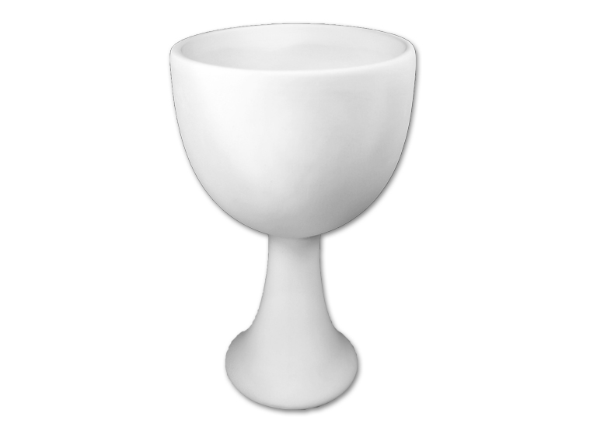 | 357 | Goblet | 6 ¾” H x 3 ¾” D | $16.00

